CS Lab 10

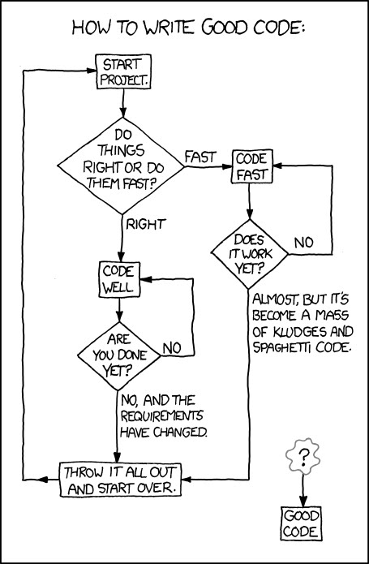**Branching and Returning**

# Preamble

Consider the following code:

**public** **class** Playground {

**public** **static** **void** main(String[] args){

Scanner myScan = **new** Scanner(System.*in*);

System.*out*.println("How much water did you drink in liters?");

String temporary;

temporary = myScan.nextLine();

**double** liters = Double.*parseDouble*(temporary);

liters += 10;

System.*out*.println("This is ten more liters: " + liters);

}

}

This gives you a way to collect a double from the user.

Now consider the following:

**public** **class** Playground {

**public** **static** **void** main(String[] args){

**double** money = 520.045;

System.*out*.printf("$%2.2f", money);

System.*out*.println("");

String thisWay = String.*format*("$%,.2f", money);

System.*out*.println(thisWay);

}

}

This prints out:

$520.05

$520.05

Which gives you one way to display a double as money, and one way to save it formatted that way as a String.

The code in this lab do not require any main methods or printlns. It will be up to you to create a class with a main method to test your code appropriately. Remember: test early, test often! You do not need to submit your testing (runner) class, only the specified files. Make sure to place all files in an appropriately named folder.

# Part 1:

**Filename**: TaxCalc.java

In the US, we use graduated taxes. The federal tax rates in 2012 were:

0% if you made less than or equal to $17,400. If you made more than this, this money was taxed at 10%.

Everything from $17,400 and $70,699.99 was taxed at 15%.

Everything between $70,700 and $142,699.99 was taxed at 25%.

Everything between $142,700 and $217,449.99 was taxed at 28%.

Finally, anything $217,450 and up was taxed at 33%.

This means that, if a person had an income of 18,000, they would pay ($17,400 * .10) + ($600 * .15). This is what is meant by a *graduated* tax rate. There was a proposal in 2012 to give everyone with an income at or above $217,450 an *ungraduated* tax rate of 33%. Everyone else would have had their taxes unchanged.

Please write a Java class called TaxCalc with three methods:

/* oldTax returns the old tax, rounded to the nearest penny, properly formatted with dollar signs and commas, such as “$4,564.25 */

public String oldTax(double income)

/* newTax returns the net tax in the same format as above */

public String newTax(double income)

/* taxDifference returns the new tax minus the old tax. For low incomes, should return “$0.00” */

public String taxDifference(double income)

# Part 2:

**Filename**: DiscountCalc.java

Crazy savings has a crazy discount plan! If you purchase 1-5 items, you get the SPECIAL savings rate, but if you purchase 6-10 items, you get the SUPER SPECIAL rate. If you purchase between 11 and 20 items, Crazy Savings will not provide a discount at all (though their teenage cashier Stanley and Loretta the custodian will sing a wildly unenthusiastic rendition of “Happy Purchase To You” over the loudspeaker). Finally, if you purchase more than 20 items, you will get the SPECIAL savings rate.

The SPECIAL savings rate is 10%, and the SUPER SPECIAL rate is 9% (yes, you read that right).

In DiscountCalc, please create one method that returns the discount on a given purchase. Additionally, make sure that the cost is properly rounded to the nearest penny. (Any double can be rounded to the nearest hundredth with a line of code akin to:

Cost = ((int)((100*Cost)+.5))/100.0;

We will learn to dissect that line of code in the next unit. In the meantime, here is your method header:

public double calculateTheDiscount(int numOfItems, double cost)

# Part 3:

**Filename**: TwelveDays.java

Please use a switch/case statement to write the full lyrics to The Twelve Days of Christmas (with modified lyrics, found below). You should use a “for” loop around it. The entire output should be a single returned String. A few hints:

You will need to use “\n” to insert newlines.

You will need a switch/case for the first three words of each day (“On the first”, “On the second”, etc.) and for the remainder of the verses.

You will only need ONE “break;” statement in the second switch/case statement to account for the slightly different last line. You may choose to do this with an IF statement in the 1 case instead.

Please create this in a method that returns a String called “singThatSong()”.

On the first day of high school, my teacher gave to me

A lecture about my workload.

On the second day of high school, my teacher gave to me

Two problem sets

And a lecture about my workload.

On the third day of high school, my teacher gave to me

Three rough drafts

Two problem sets

And a lecture about my workload.

On the fourth day of high school, my teacher gave to me

Four hundred emails

Three rough drafts

Two problem sets

And a lecture about my workload.

On the fifth day of high school, my teacher gave to me

Five Shakespeare plays!

Four hundred emails

Three rough drafts

Two problem sets

And a lecture about my workload.

On the sixth day of high school, my teacher gave to me

Six chapters' reading

Five Shakespeare plays!

Four hundred emails

Three rough drafts

Two problem sets

And a lecture about my workload.

On the seventh day of high school, my teacher gave to me

Seven lab reports

Six chapters' reading

Five Shakespeare plays!

Four hundred emails

Three rough drafts

Two problem sets

And a lecture about my workload.

On the eighth day of high school, my teacher gave to me

Eight examinations

Seven lab reports

Six chapters' reading

Five Shakespeare plays!

Four hundred emails

Three rough drafts

Two problem sets

And a lecture about my workload.

On the ninth day of high school, my teacher gave to me

Nine performance skits

Eight examinations

Seven lab reports

Six chapters' reading

Five Shakespeare plays!

Four hundred emails

Three rough drafts

Two problem sets

And a lecture about my workload.

On the tenth day of high school, my teacher gave to me

Ten Practice Problems

Nine performance skits

Eight examinations

Seven lab reports

Six chapters' reading

Five Shakespeare plays!

Four hundred emails

Three rough drafts

Two problem sets

And a lecture about my workload.

On the eleventh day of high school, my teacher gave to me

Eleven vocab lists

Ten Practice Problems

Nine performance skits

Eight examinations

Seven lab reports

Six chapters' reading

Five Shakespeare plays!

Four hundred emails

Three rough drafts

Two problem sets

And a lecture about my workload.

On the twelfth day of high school, my teacher gave to me

Twelve lunch detentions

Eleven vocab lists

Ten Practice Problems

Nine performance skits

Eight examinations

Seven lab reports

Six chapters' reading

Five Shakespeare plays!

Four hundred emails

Three rough drafts

Two problem sets

And a lecture about my workload.

# Optional Challenge:

**Filename**: TDG.java

Code Golf is a game of trying to create code that accomplishes a task with the *fewest number of characters in your code possible*. There will be a Code Golf challenge with the Twelve Days code. The pair that creates a fully functional Java version of Twelve Days of High School with the fewest characters will be the winner with bragging rights. The output must remain the same, but there are absolutely no other constraints.

In the spirit of Code Golf, the method used to call the song will be called “s()” in this version of the code.